Assignment – 10
The management requires you to add more functionalities to the wallet object we created in the last assignment (refer assignment 9 for objects). Now the management wants you to add more logic to the module:
● Introduce a field wallet balance which is a formula field updated as wallet balance– bill amount.
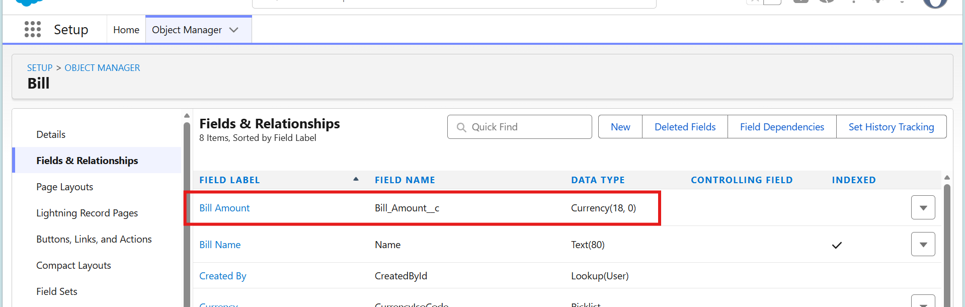
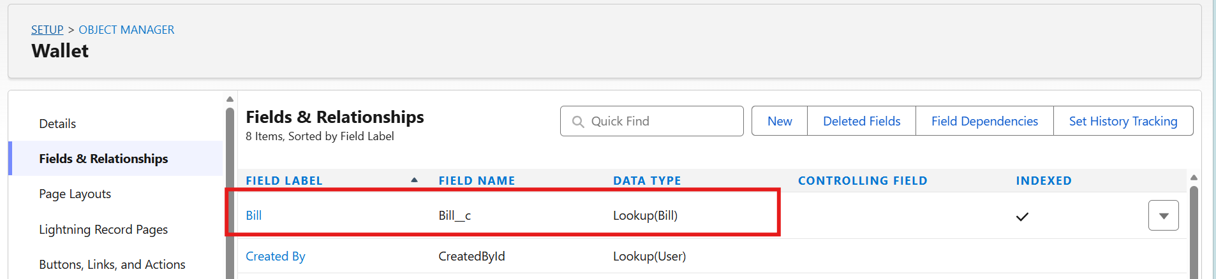
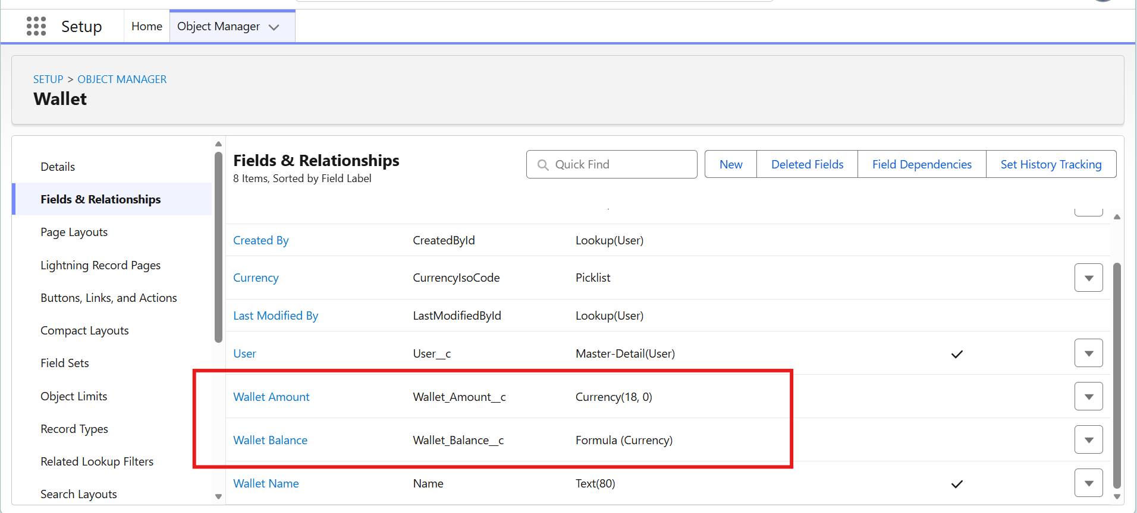
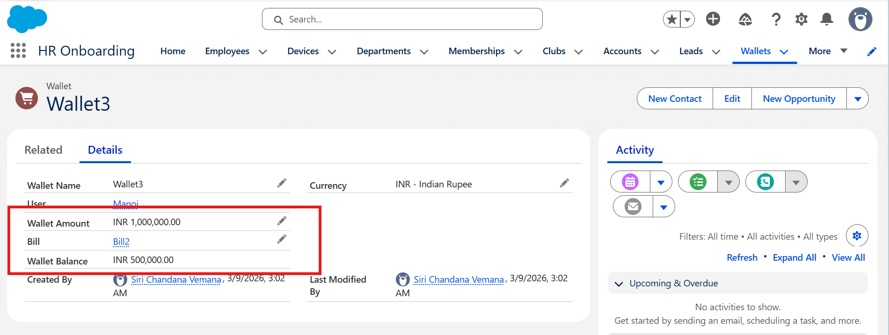
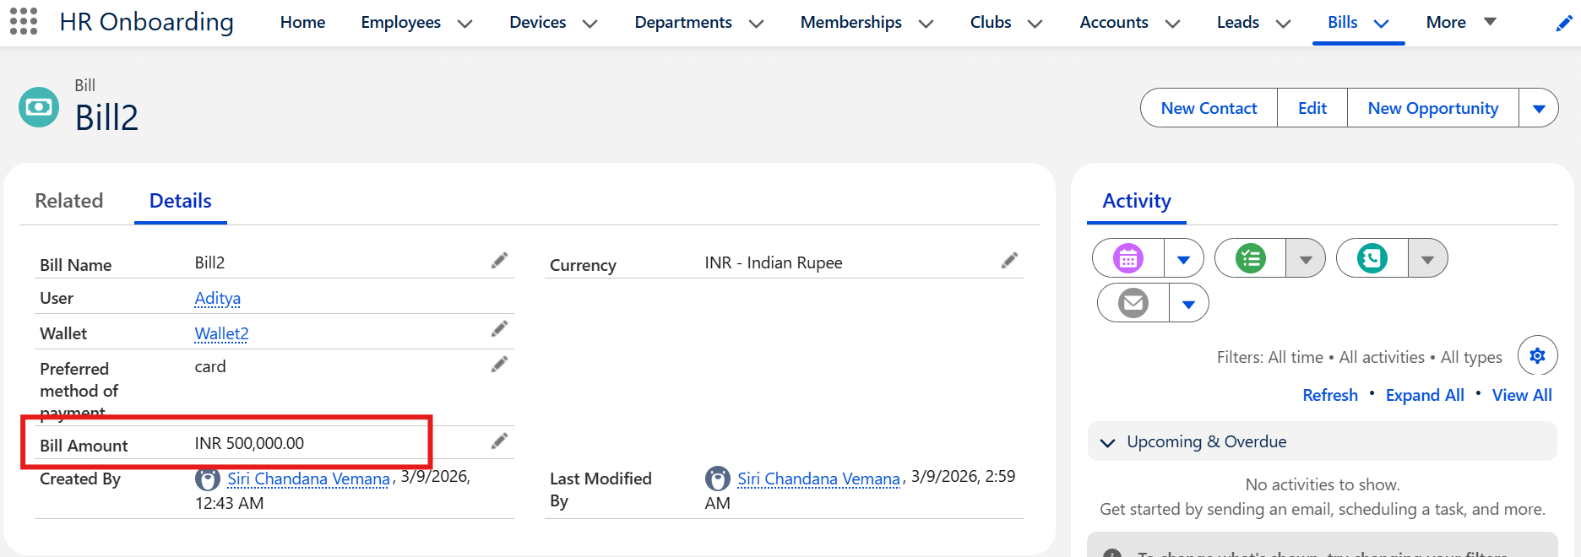
● The field in wallet: wallet balance should have a validation process where wallet balance should never be negative.

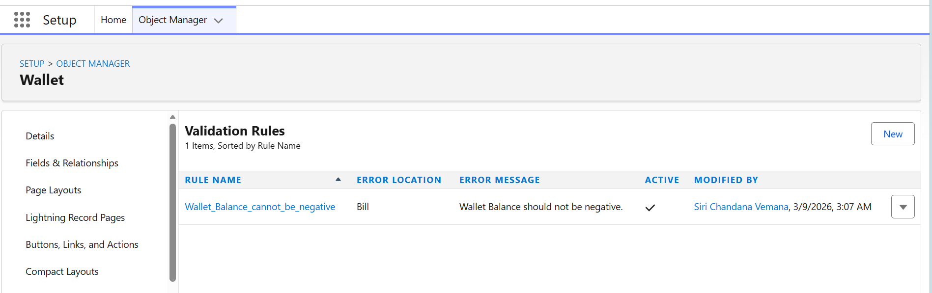

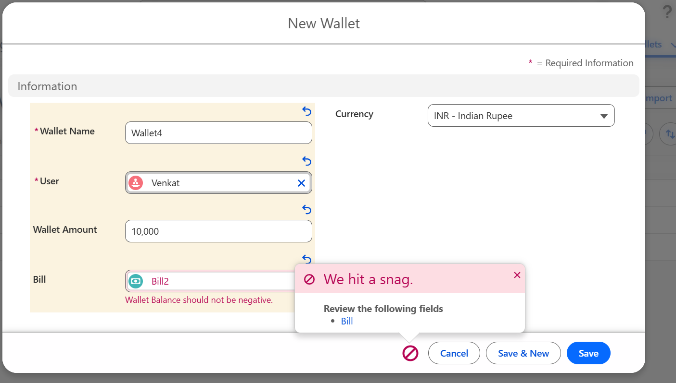

● Create a process that sends a mail if the wallet balance is less than 100.
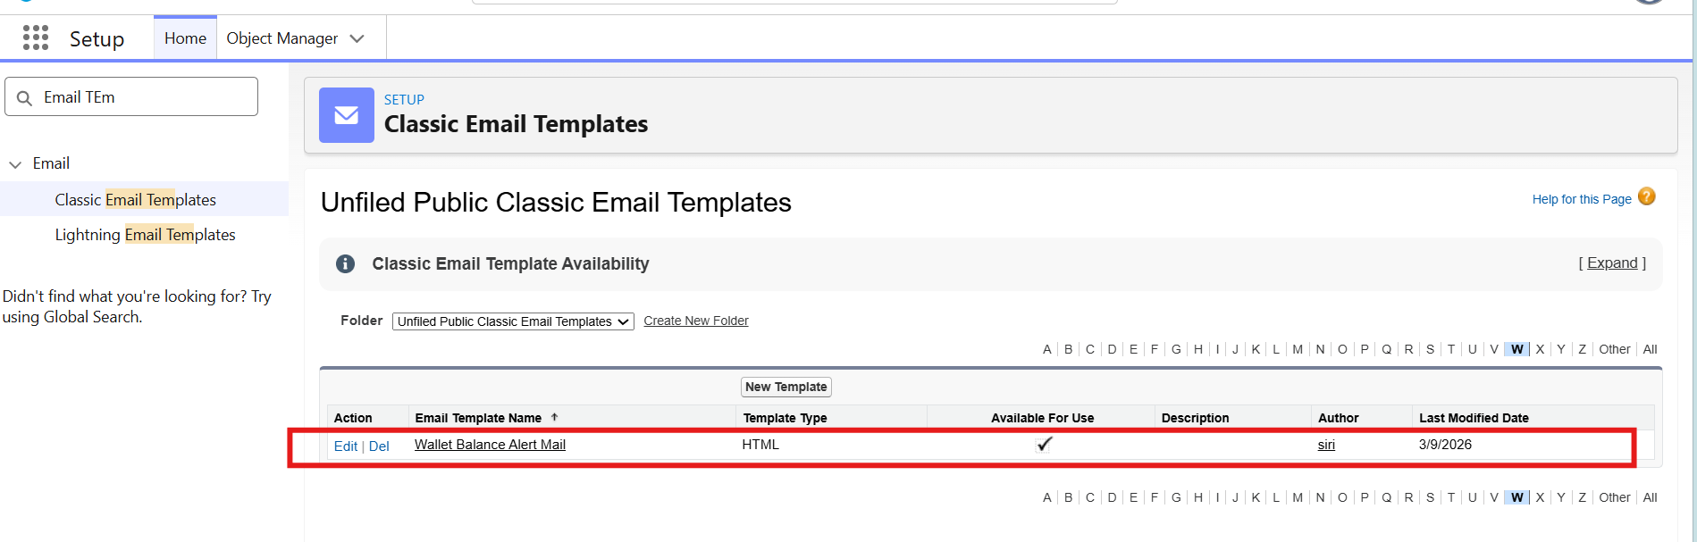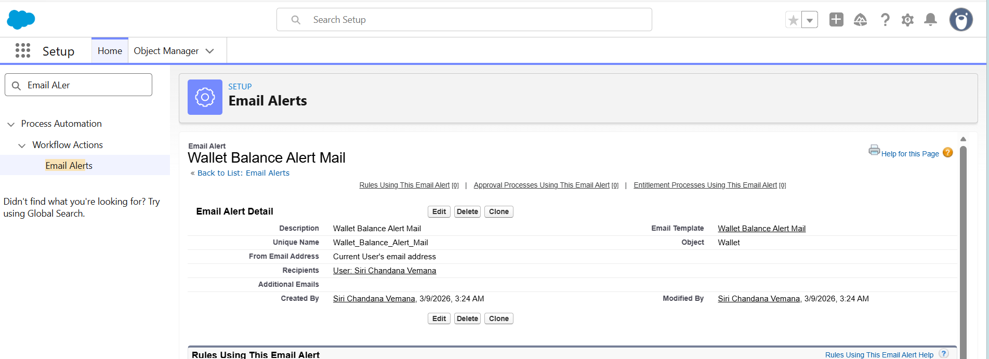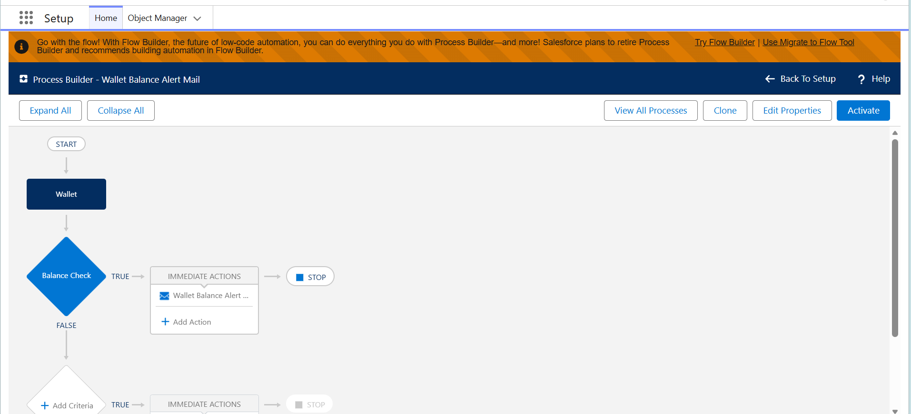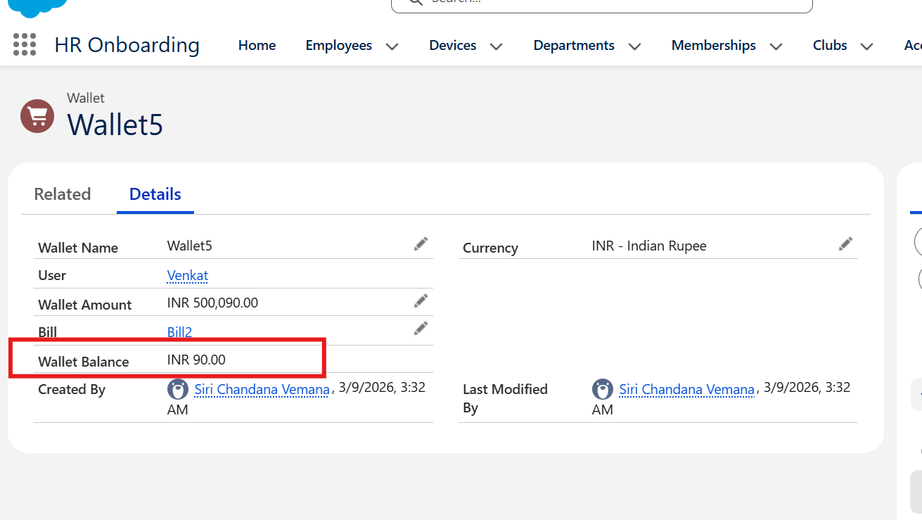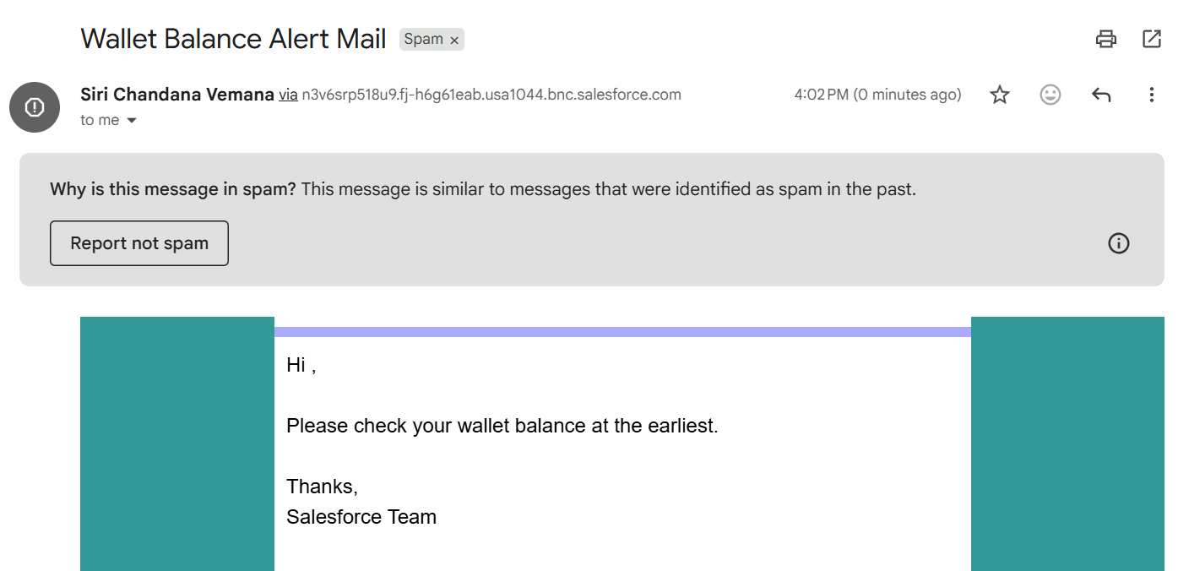

● A roll up summary having sum of the entire bill generated to the user so far.
